**CHAPTER 1**

**INTRODUCTION**

Java is one of the programming language or technology used for developing web applications. Java language developed at SUN Micro Systems in the year 1995 under the guidance of James Gosling and there team. Originally SUN Micro Systems is one of the Academic university (Standford University Network)

Whatever the software developed in the year 1990, SUN Micro Systems has released on the name of oak, which is original name of java (scientifically oak is one of the tree name). The OAK has taken 18 months to develop. The oak is unable to fulfill all requirements of the industry. So James Gosling again reviews this oak and released with the name of java in the year 1995. Scientifically java is one of the coffee seed name.

**Java divided into three categories, they are**

* J2SE (Java 2 Standard Edition)
* J2EE (Java 2 Enterprise Edition)
* J2ME (Java 2 Micro or Mobile Edition)

## 1.1 Overview Of Java

Java is a platform independent, more powerful, secure, high performance, multithreaded programming language. Here we discuss some points related to java. Jvm, Jre, Jdk these all the backbone of java language. Each components have separate works. Jdk and Jre physically exists but Jvm are abstract machine it means it not physically exists.

**JVM :** JVM (Java Virtual Machine) is a software. It is a specification that provides runtime environment in which java bytecode can be executed. It not physically exists. JVMs are not same for all hardware and software, for example for windows JVM is different and for Linux JVM is different. JVM, JRE and JDK are platform dependent because configuration of each OS differs. But, Java is platform independent.

**JRE :** The Java Runtime Environment (JRE) is part of the Java Development Kit (JDK). It contains set of libraries and tools for developing java application. The Java Runtime Environment provides the minimum requirements for executing a Java application. It physically exists. It contains set of libraries + other files that JVM uses at runtime.

**JDK** : The Java Development Kit (JDK) is primary components. It physically exists. It is collection of programming tools and JRE, JVM.

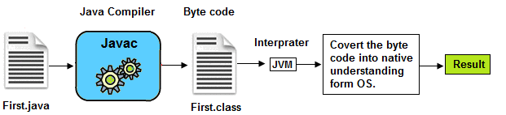

**Fig.1.1 Converting of .java file to byte code**

**1.2 Interface**

Interface is similar to class which is collection of public static final variables (constants) and abstract methods. The interface is a mechanism to achieve fully abstraction in java. There can be only abstract methods in the interface. It is used to achieve fully abstraction and multiple inheritance in Java.

**Why we use Interface ?**

* It is used to achieve fully abstraction.
* By using Interface, you can achieve multiple inheritance in java.

## 1.3 Inheritance

The process of obtaining the data members and methods from one class to another class is known as **inheritance**. It is one of the fundamental features of object-oriented programming.

A class that is declared with abstract keyword, is known as **abstract class**. An abstract class is one which is containing some defined method and some undefined method. In java programming undefined methods are known as un-Implemented or abstract method.The process of obtaining the data members and methods from one class to another class is known as **inheritance**. It is one of the fundamental features of object-oriented programming.

**Why use Inheritance ?**

For Method Overriding (used for Runtime Polymorphism).

It's main uses are to enable polymorphism and to be able to reuse code for different classes by putting it in a common super class

For code Re-usability

**1.4 Main( ) Method**

main() method is starting execution block of a java program or any java program start their execution from main method. If any class contain main() method known as main class.

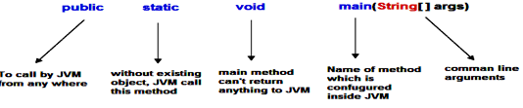**Fig.1.2** main Method in java

**Static block**

Static block is a set of statements, which will be executed by the JVM before execution of main method. At the time of class loading if we want to perform any activity we have to define that activity inside static block because static block execute at the time of class loading.

In a class we can take any number of static block but all these static block will be execute from top to bottom.

**Constructor**

A **constructor** is a special member method which will be called implicitly (automatically) by the JVM whenever an object is created for placing user or programmer defined values in place of default values. In a single word constructor is a special member method which will be called automatically whenever object is created.

The purpose of constructor is to initialize an object called object initialization. Constructors are mainly create for initializing the object. Initialization is a process of assigning user defined values at the time of allocation of memory space.

**Types of constructors**

Based on creating objects in Java constructor are classified in two types. They are

* Default or no argument Constructor
* Parameterized constructor.

**1.5 Features Of JAVA**

Features of a language are nothing but the set of services or facilities provided by the language vendors to the industry programmers. Some important features are;

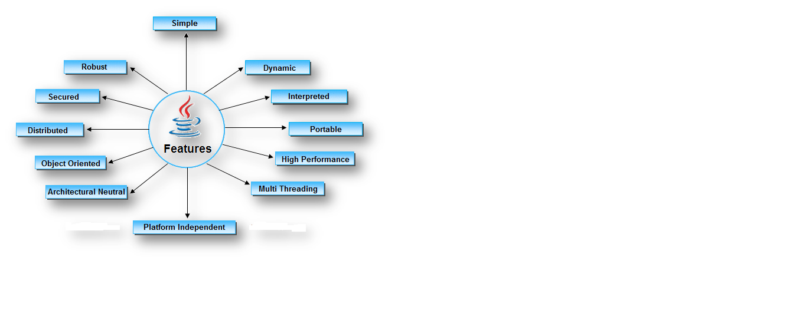

**Fig.1.3** Features of java

## 1.6 INTRODUCTION OF PROJECT

## This project is like an exam test. In which I have written some questions and also their options. I used JRadioButton ( class is used to create a radio button. It is used to choose one option from multiple options. It is widely used in exam systems or quiz. It should be added in ButtonGroup to select one radio button only.) to select an option from out of four. To create button I used JButton (class is used to create a labeled button that has platform independent implementation. The application result in some action when the button is pushed. It inherits AbstractButton class). I also added there a button (bookmark) to select your questions if you have doubt on it and you can change its answer later. I added a button (next) to go on next question. I added ten questions here and all with four choices. At last after answering ten questions there will be a button (result). This button is used to tell you how many right answers you have given. In this it give you a message the number of correct answer. This project is very useful to make an online test. This project is used to save time and to reduce efforts.

## CHAPTER 2

## HARDWARE AND SOFTWARE

**2.1 Software**

* Eclipse

**2.2 Hardware**

* Monitor
* Mouse
* CPU
* Keyboard

**CHAPTER 3**

**SOURCE CODE OF PROJECT**

**3.1 Source Code**

**import** java.awt.*;

**import** java.awt.event.*;

**import** javax.swing.*;

**class** OnlineTest **extends** JFrame **implements** ActionListener

{

JLabel l;

JRadioButton jb[]=**new** JRadioButton[5];

JButton b1,b2;

ButtonGroup bg;

**int** count=0,current=0,x=1,y=1,now=0;

**int** m[]=**new** **int**[10];

OnlineTest(String s)

{

**super**(s);

l=**new** JLabel();

add(l);

bg=**new** ButtonGroup();

**for**(**int** i=0;i<5;i++)

{

jb[i]=**new** JRadioButton();

add(jb[i]);

bg.add(jb[i]);

}

b1=**new** JButton("Next");

b2=**new** JButton("Bookmark");

b1.addActionListener(**this**);

b2.addActionListener(**this**);

add(b1);add(b2);

set();

l.setBounds(30,40,450,20);

jb[0].setBounds(50,80,100,20);

jb[1].setBounds(50,110,100,20);

jb[2].setBounds(50,140,100,20);

jb[3].setBounds(50,170,100,20);

b1.setBounds(100,240,100,30);

b2.setBounds(270,240,100,30);

setDefaultCloseOperation(JFrame.***EXIT_ON_CLOSE***);

setLayout(**null**);

setLocation(250,100);

setVisible(**true**);

setSize(600,350);

}

**public** **void** actionPerformed(ActionEvent e)

{

**if**(e.getSource()==b1)

{

**if**(check())

count=count+1;

current++;

set();

**if**(current==9)

{

b1.setEnabled(**false**);

b2.setText("Result");

}

}

**if**(e.getActionCommand().equals("Bookmark"))

{

JButton bk=**new** JButton("Bookmark"+x);

bk.setBounds(480,20+30*x,100,30);

add(bk);

bk.addActionListener(**this**);

m[x]=current;

x++;

current++;

set();

**if**(current==9)

b2.setText("Result");

setVisible(**false**);

setVisible(**true**);

}

**for**(**int** i=0,y=1;i<x;i++,y++)

{

**if**(e.getActionCommand().equals("Bookmark"+y))

{

**if**(check())

count=count+1;

now=current;

current=m[y];

set();

((JButton)e.getSource()).setEnabled(**false**);

current=now;

}

}

**if**(e.getActionCommand().equals("Result"))

{

**if**(check())

count=count+1;

current++;

//System.out.println("correct ans="+count);

JOptionPane.*showMessageDialog*(**this**,"correct ans="+count);

System.*exit*(0);

}

}

**void** set()

{

jb[4].setSelected(**true**);

**if**(current==0)

{

l.setText("Que1: Which one among these is not a primitive datatype?");

jb[0].setText("int");jb[1].setText("Float");jb[2].setText("boolean");jb[3].setText("char");

}

**if**(current==1)

{

l.setText("Que2: Which class is available to all the class automatically?");

jb[0].setText("Swing");jb[1].setText("Applet");jb[2].setText("Object");jb[3].setText("ActionEvent");

}

**if**(current==2)

{

l.setText("Que3: Which package is directly available to our class without importing it?");

jb[0].setText("swing");jb[1].setText("applet");jb[2].setText("net");jb[3].setText("lang");

}

**if**(current==3)

{

l.setText("Que4: String class is defined in which package?");

jb[0].setText("lang");jb[1].setText("Swing");jb[2].setText("Applet");jb[3].setText("awt");

}

**if**(current==4)

{

l.setText("Que5: Which institute is best for java coaching?");

jb[0].setText("Utek");jb[1].setText("Aptech");jb[2].setText("SSS IT");jb[3].setText("jtek");

}

**if**(current==5)

{

l.setText("Que6: Which one among these is not a keyword?");

jb[0].setText("class");jb[1].setText("int");jb[2].setText("get");jb[3].setText("if");

}

**if**(current==6)

{

l.setText("Que7: Which one among these is not a class? ");

jb[0].setText("Swing");jb[1].setText("Actionperformed");jb[2].setText("ActionEvent");

jb[3].setText("Button");

}

**if**(current==7)

{

l.setText("Que8: which one among these is not a function of Object class?");

jb[0].setText("toString");jb[1].setText("finalize");jb[2].setText("equals");

jb[3].setText("getDocumentBase");

}

**if**(current==8)

{

l.setText("Que9: which function is not present in Applet class?");

jb[0].setText("init");jb[1].setText("main");jb[2].setText("start");jb[3].setText("destroy");

}

**if**(current==9)

{

l.setText("Que10: Which one among these is not a valid component?");

jb[0].setText("JButton");jb[1].setText("JList");jb[2].setText("JButtonGroup");

jb[3].setText("JTextArea");

}

l.setBounds(30,40,450,20);

**for**(**int** i=0,j=0;i<=90;i+=30,j++)

jb[j].setBounds(50,80+i,200,20);

}

**boolean** check()

{

**if**(current==0)

**return**(jb[1].isSelected());

**if**(current==1)

**return**(jb[2].isSelected());

**if**(current==2)

**return**(jb[3].isSelected());

**if**(current==3)

**return**(jb[0].isSelected());

**if**(current==4)

**return**(jb[2].isSelected());

**if**(current==5)

**return**(jb[2].isSelected());

**if**(current==6)

**return**(jb[1].isSelected());

**if**(current==7)

**return**(jb[3].isSelected());

**if**(current==8)

**return**(jb[1].isSelected());

**if**(current==9)

**return**(jb[2].isSelected());

**return** **false**;

}

**public** **static** **void** main(String s[])

{

**new** OnlineTest("Online Test Of Java");

}

}

// the result of this code is shown on next page

**CHAPTER 4**

**RESULTS**

In this you can see different images to learn about result

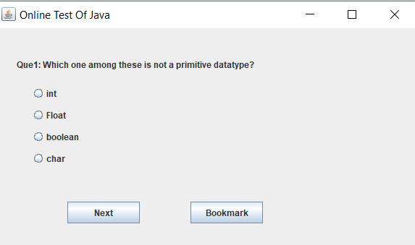

**Fig. 4.1** showing question with choices

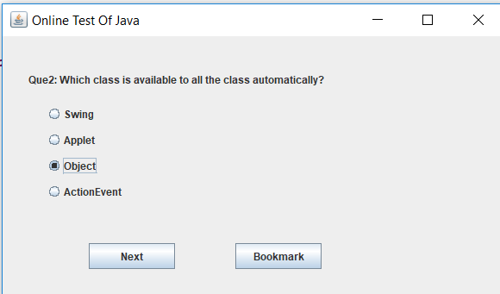

**Fig. 4.2** one choice is selected

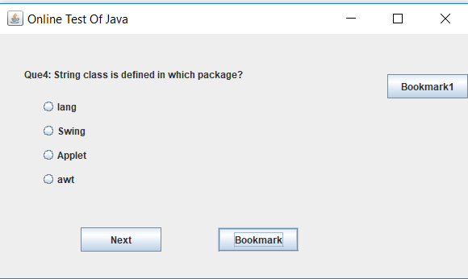

**Fig. 4.3** added in bookmark

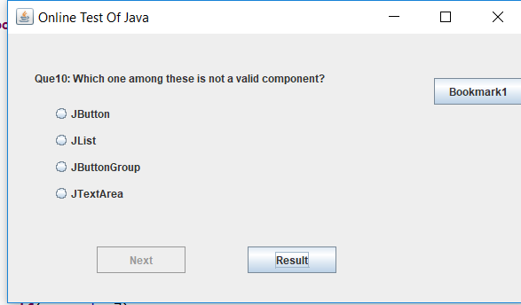

**Fig. 4.4** Result button is created

Here in fig. 4.1 you can see the question with four choices and there are two buttons next and bookmark.

In fig. 4.2 you can see choices has been selected by clicking on it.

In fig 4.3 you can see that question has been put in bookmark by clicking on Bookmark button.

In fig. 4.4 you can see that after ten questions result has been created.

In fig. 4.5 you can see that after clicking on result button the number of right answers has been shown by a message.

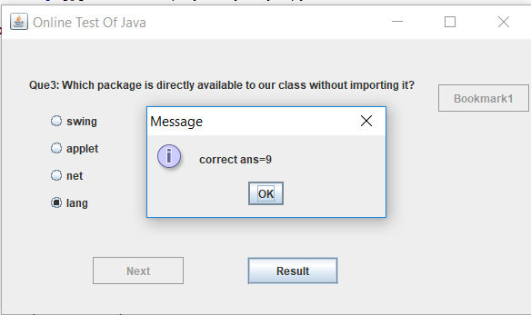

**Fig. 4.5** To give Message

**CHAPTER 5**

**FUTURE SCOPE**

By considering above project you can easily understand that here may be many future scopes in this project. Some of those are,

1. It can be use as online test.
2. It can be use as a game.
3. It can be use as for practice work.
4. It can be use as a puzzle game.

**CONCLUSIONS**

Practical knowledge means the visualization of the knowledge, which we read in our books. For this, we perform experiments and get observations. Practical knowledge is very important in every field. One must be familiar with the problems related to that field so that he may solve them and become a successful person.

After achieving the proper goal in life, an engineer has to enter in professional life. According to this life, he has to serve an industry, may be public or private sector or self-own. For the efficient work in the field, he must be well aware of the practical knowledge as well as theoretical knowledge.

Due to all above reasons and to bridge the gap between theory and practical, our Engineering curriculum provides a practical training of 42 days. During this period a student work in the industry and get well all type of experience and knowledge about the working of companies and hardware and software tools.

I have undergone my 42 days summer training in 3rd sem at **ICSD Tech Labs ,Panipat**. This report is based on the knowledge, which I acquired during my 42 days of summer training.

**REFRENCES**

[1] zetcode.com

[2] [www.tutorialpoints.com](http://www.tutorialpoints.com)

[3] [www.programiz.com](http://www.programiz.com)

[4] [www.javatpoint.com](http://www.javatpoint.com)